Q. Demonstrate FTP server in packet Tracer. Aim:-To demonstrate FTP server in packet tracer. Setup:
(1). 2 Pc , 1 switch, 1 server.
(2).Connect Pcs to switch and switch to server. Topology:
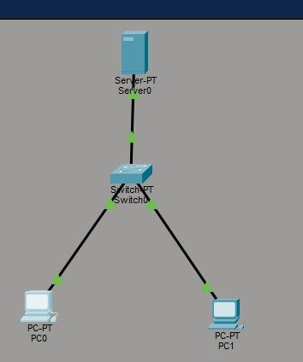

Config:
PC0
assign IP address | 192.168.1.10
Subnet Mask | 255.255.255.0
PC1
assign IP address | 192.168.1.11

Subnet Mask 255.255.255.0
Server:
(1). Enable FTP option.
(2).Create username and password(123).
- Click all the 5 tick bores write , read ,Delete ,Rename list.
- Add it.

PC0:

C:\ipconfig
C:\>ping 192.168.1.2
C:\>ftp 192.168.1.2
ftp>dir

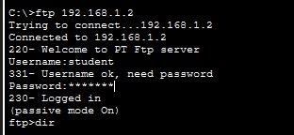

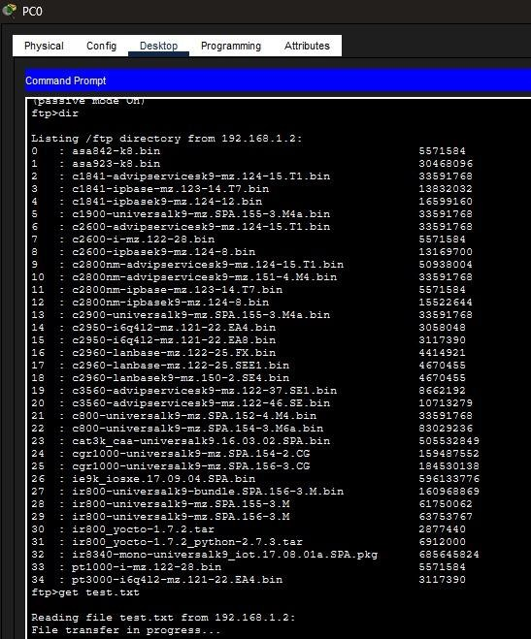

Conclusion:The above Topology has been executed successfully.

